Overview:
##### Request New Authorization Page

What we did:
setup docker container in portals project

In EAP :
run npm ci
npm run build
npm run start-with-mock

Test Data :
#### Legacy Workflow Test Customers

##### Authorisation Page
Here you have 2 input fields: CustomerNumber and ActivationCode.

CustomerNumber

* ```123456789``` Invalid login, also any other unsupported kind of 9 digits
* ```201000001``` Valid AccountID, Foreign device, SIP Data without pass
* ```201000002``` Valid AccountID, Foreign device, SIP Data with new password
* ```201000003``` Valid AccountID, Foreign device, SIP data not available
* ```201000004``` Valid AccountID, VKD device
* ```422000002``` Return 422 - docsis version too low
* ```422000003``` Return 422 - no internet contract
* ```422000004``` Return 422 - technical error
* ```422000005``` Return 422 - refurbished device
* ```422000006``` Return 422 - unassigned device
* ```400000001``` Return 400 - wrong response with HTML on GET /devices
* ```500000000``` Return 500 on login request
* ```500000001``` Return 500 on GET /devices request

ActivationCode

* Only "Test1-Test2-Test3" is a valid ActivationCode

Test1-Test2-Test3

Case1 : 123456789``` Invalid login, also any other unsupported kind of 9 digits
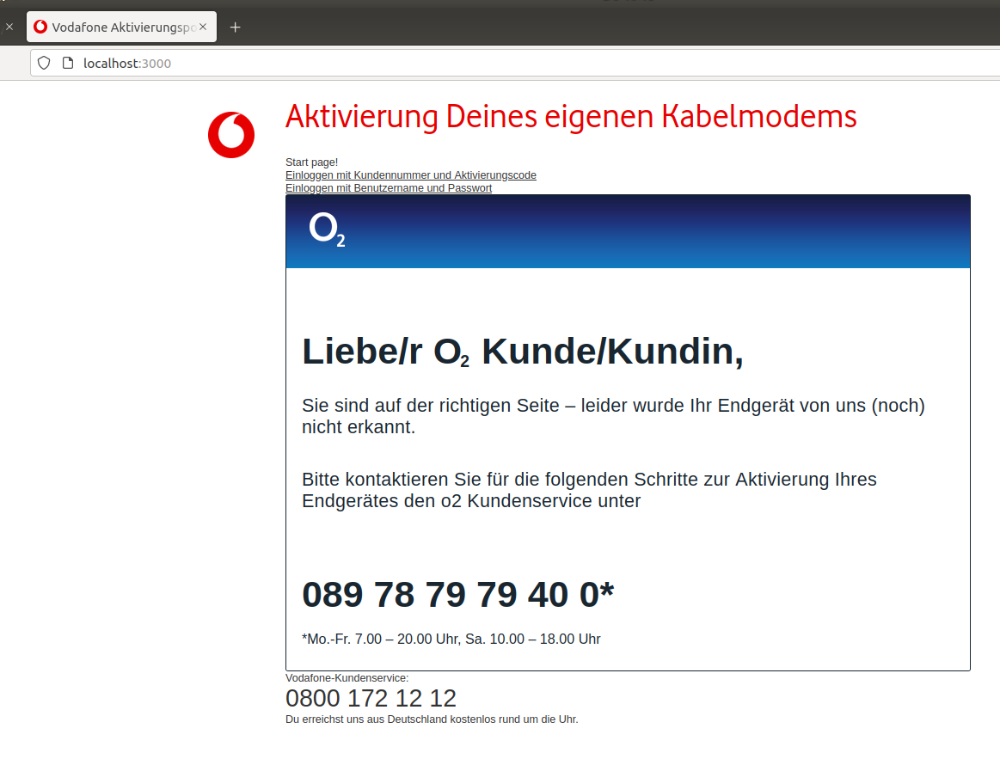

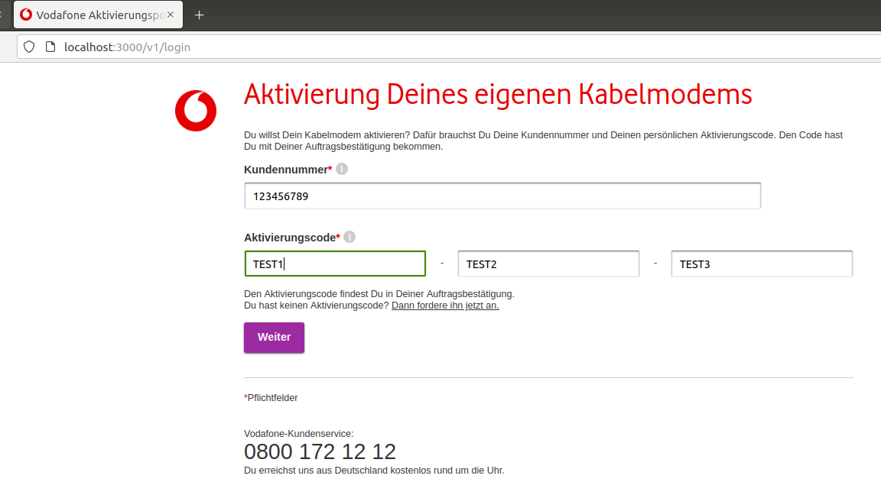

Case 2 : 201000001``` Valid AccountID, Foreign device, SIP Data without pass

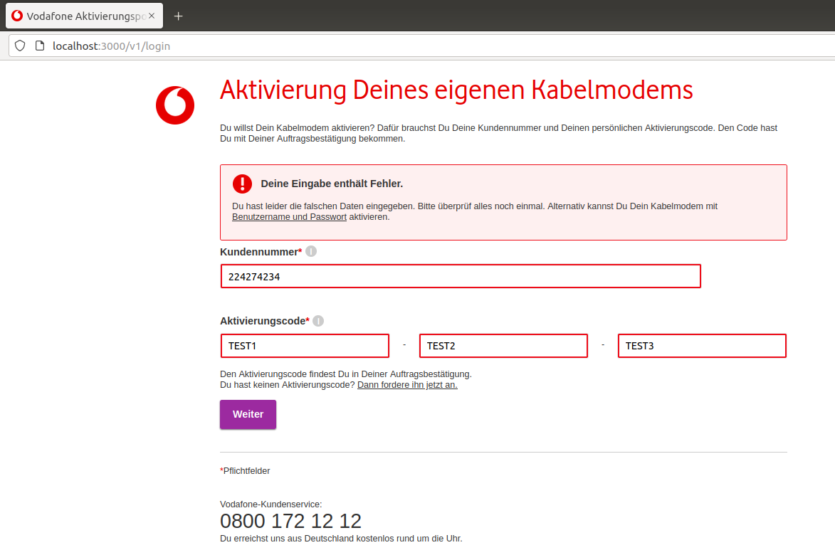

Case 3 : 201000002``` Valid AccountID, Foreign device, SIP Data with new password

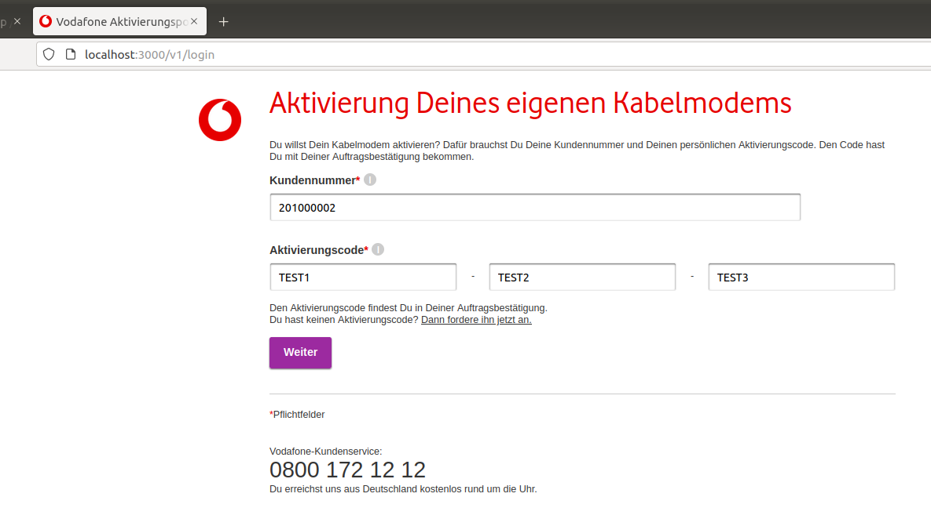
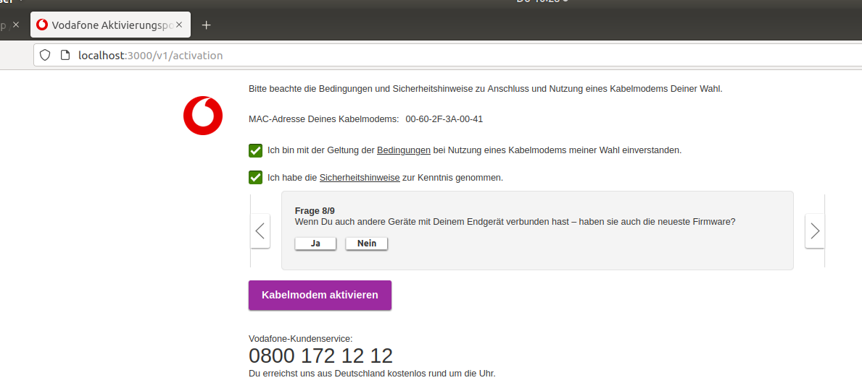

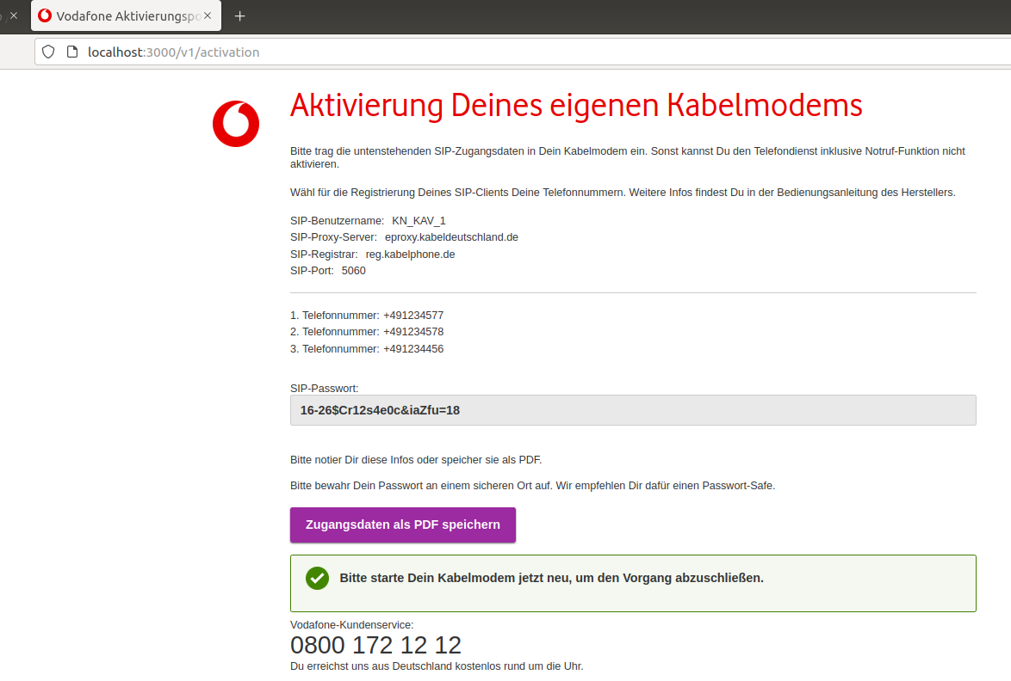

Case 4 : 201000003``` Valid AccountID, Foreign device, SIP data not available
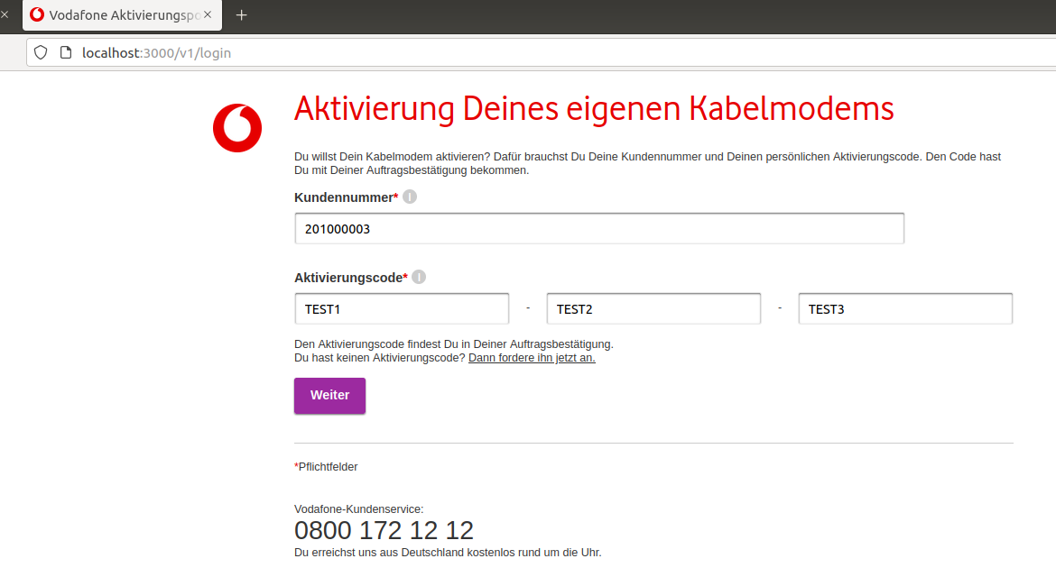

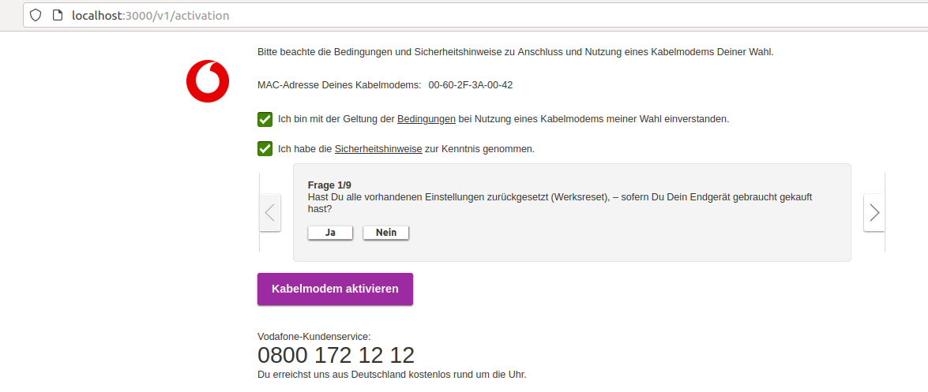

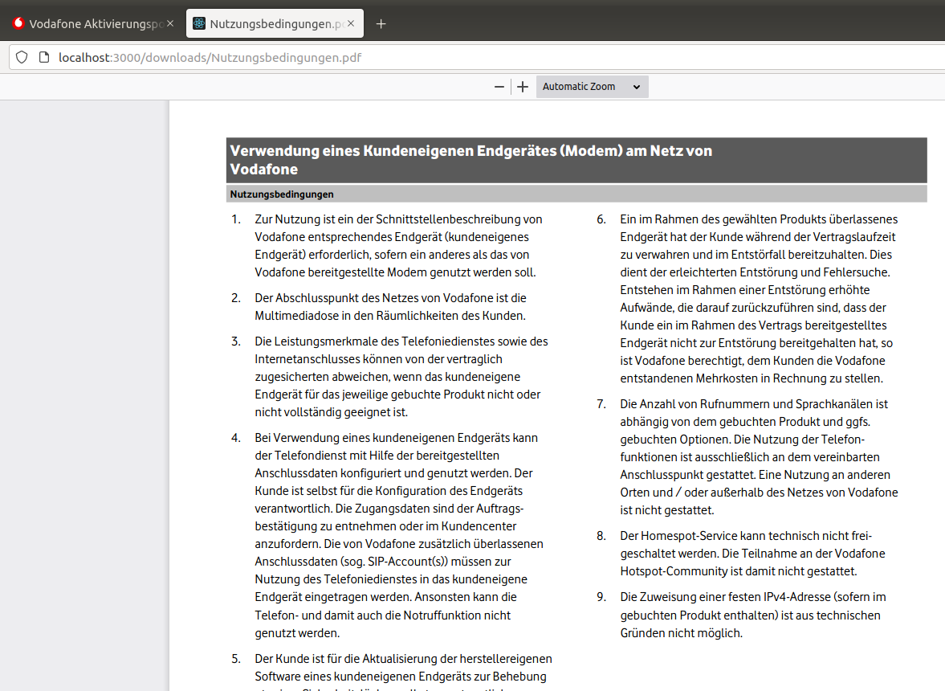

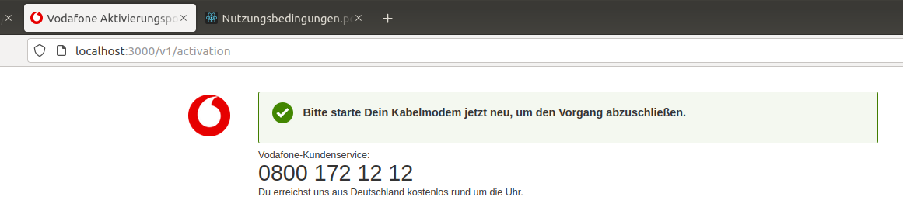

Case 5: 201000004``` Valid AccountID, VKD device

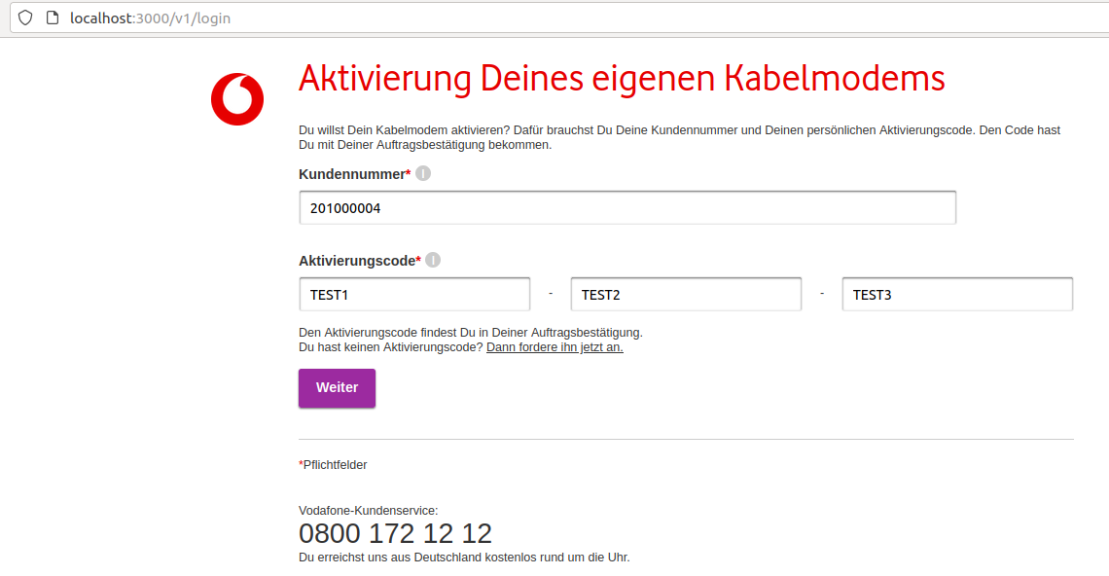

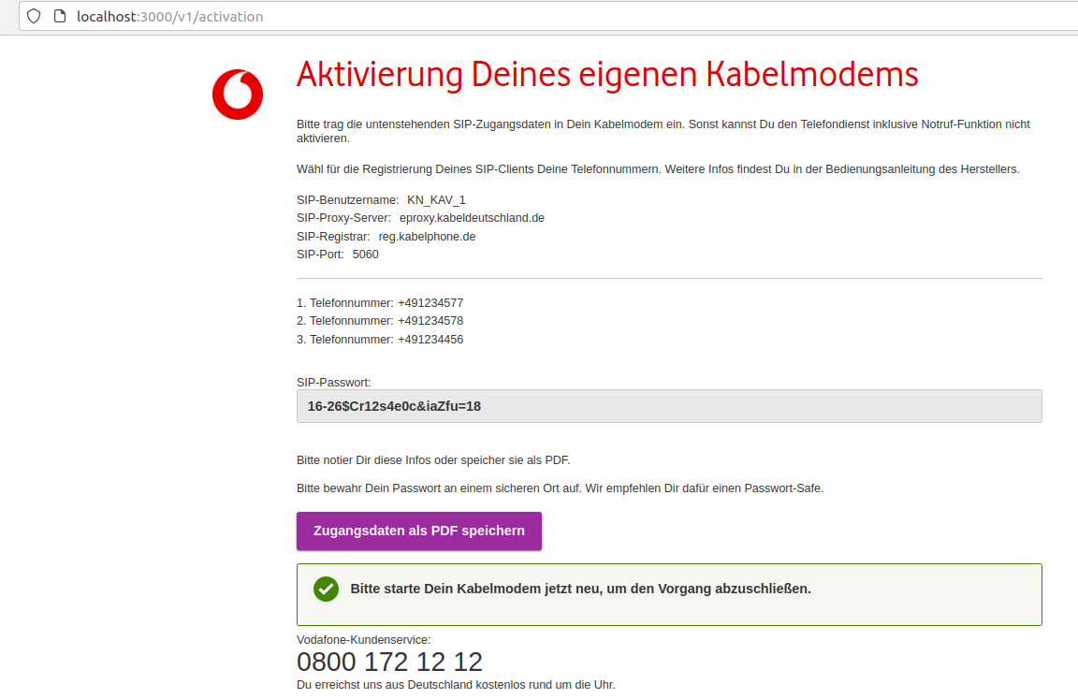
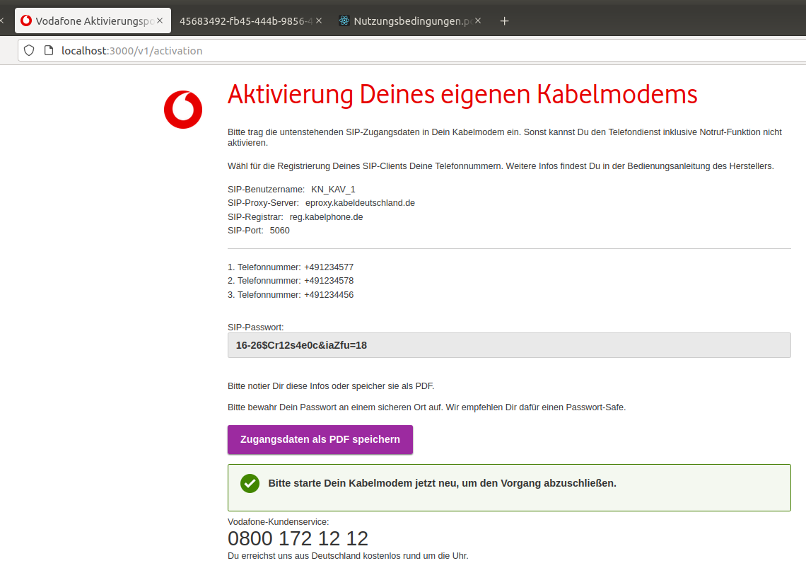

Case 6 : 422000002``` Return 422 - docsis version too low

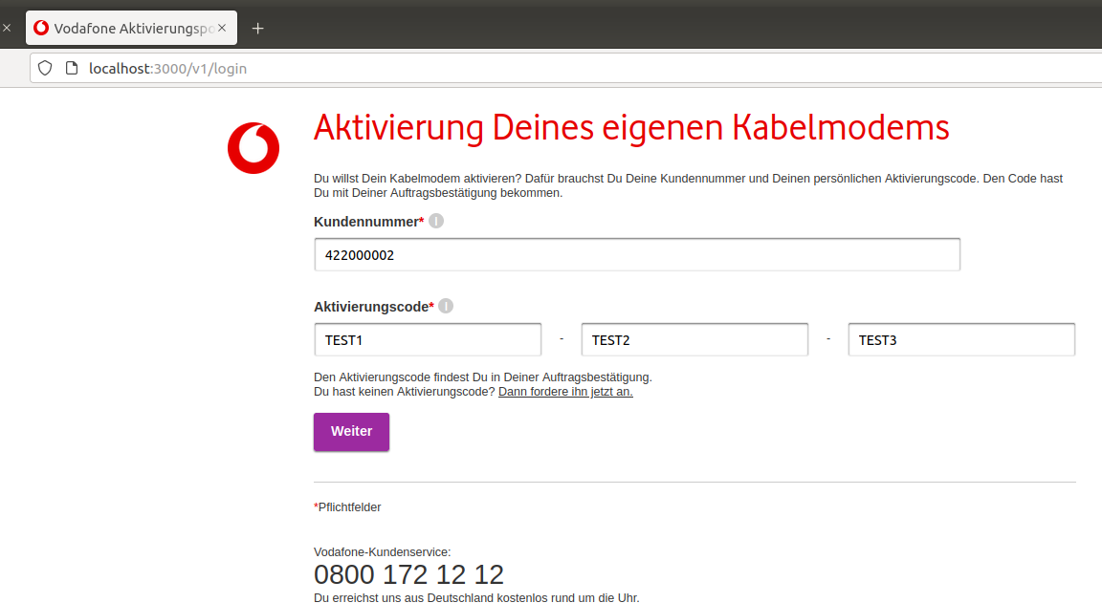

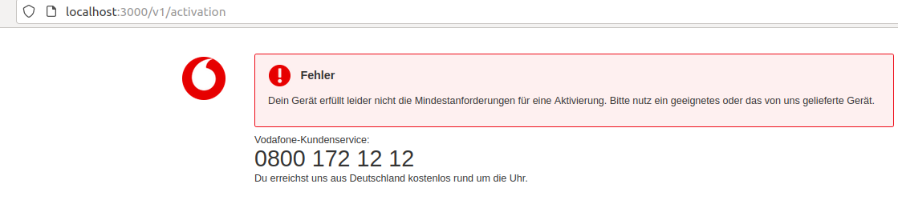

Case 7: 422000003``` Return 422 - no internet contract

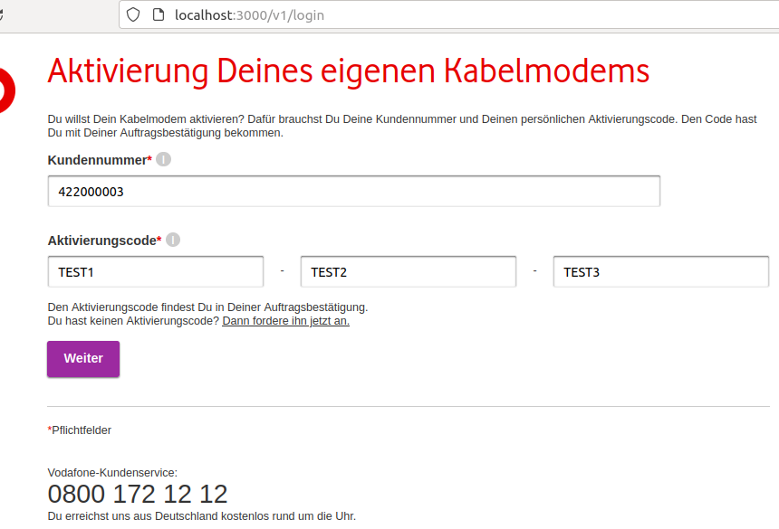

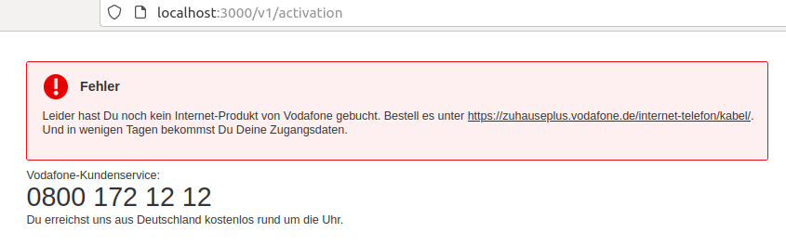
the link redirect to Zuhaus+:

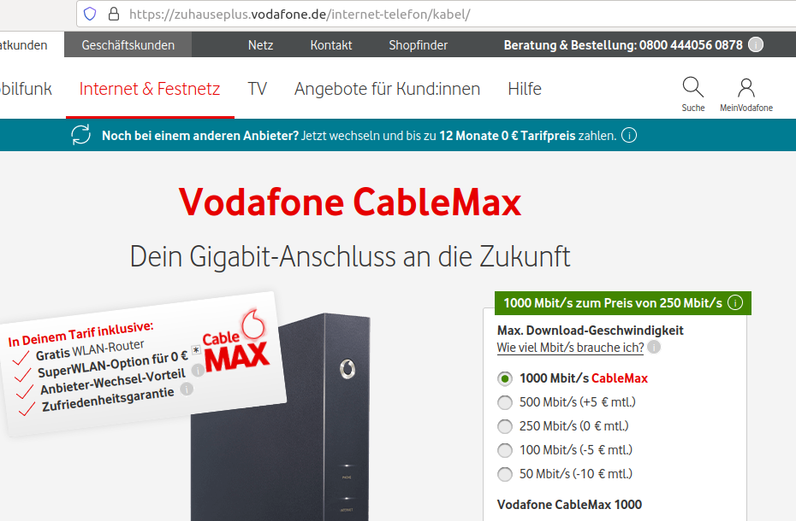

Case 8 : 422000004``` Return 422 - technical error

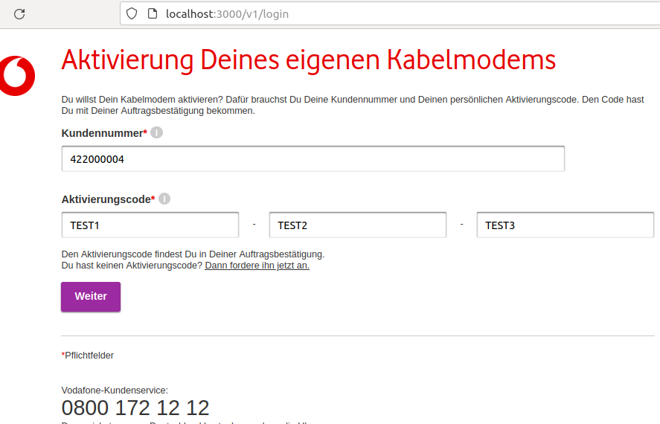

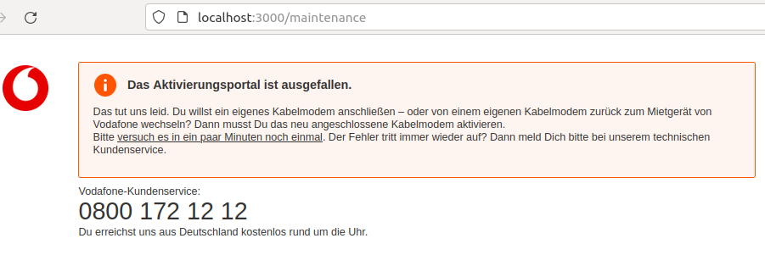

Case 9 : 422000005``` Return 422 - refurbished device

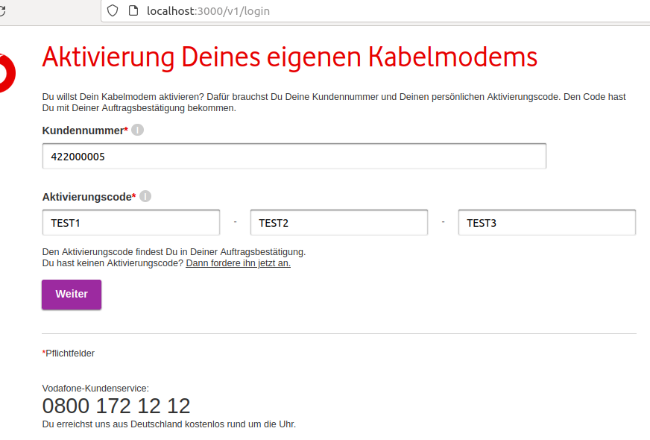

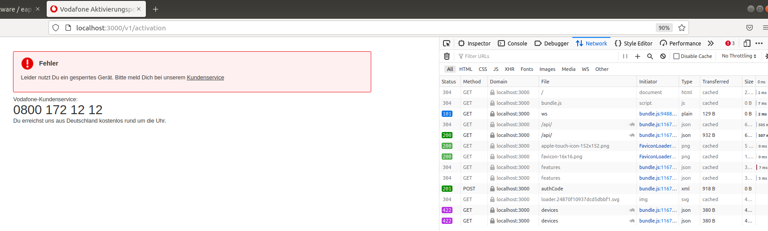

Case 10 : 422000006``` Return 422 - unassigned device

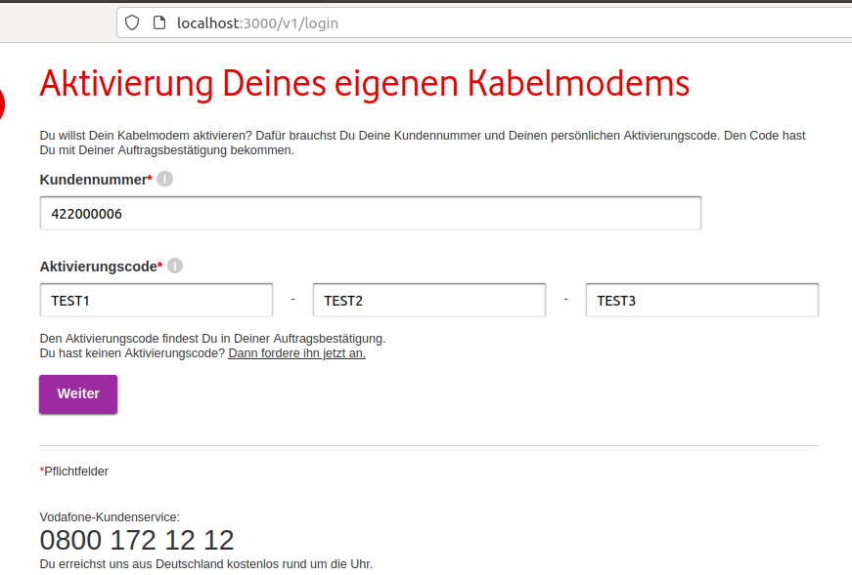

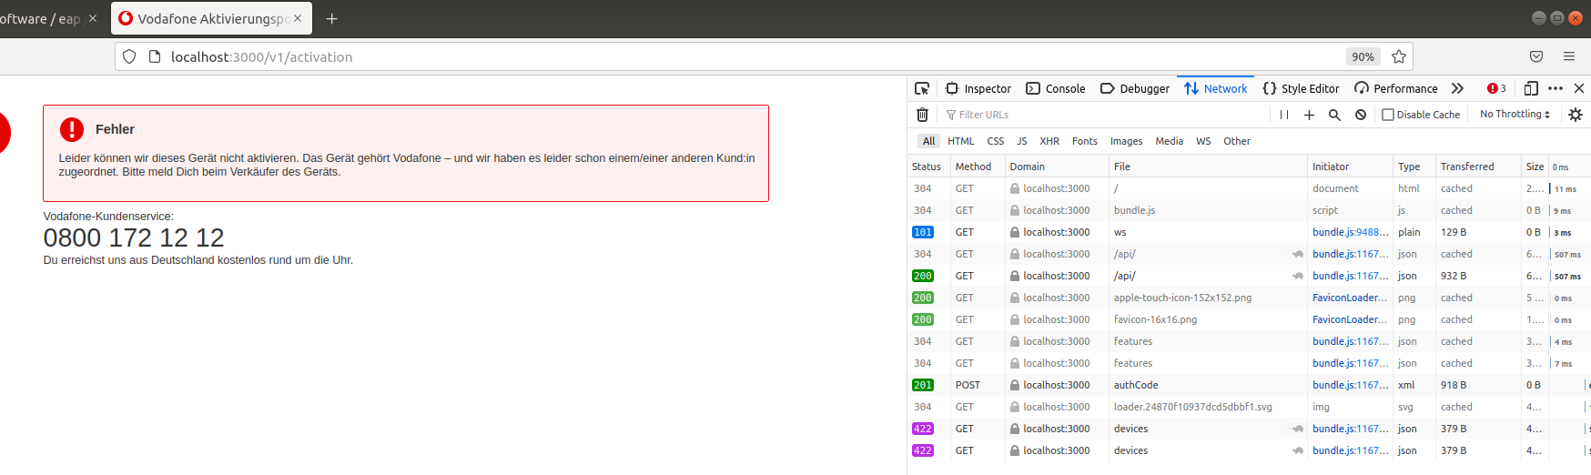

Case 11 : 400000001``` Return 400 - wrong response with HTML on GET /devices

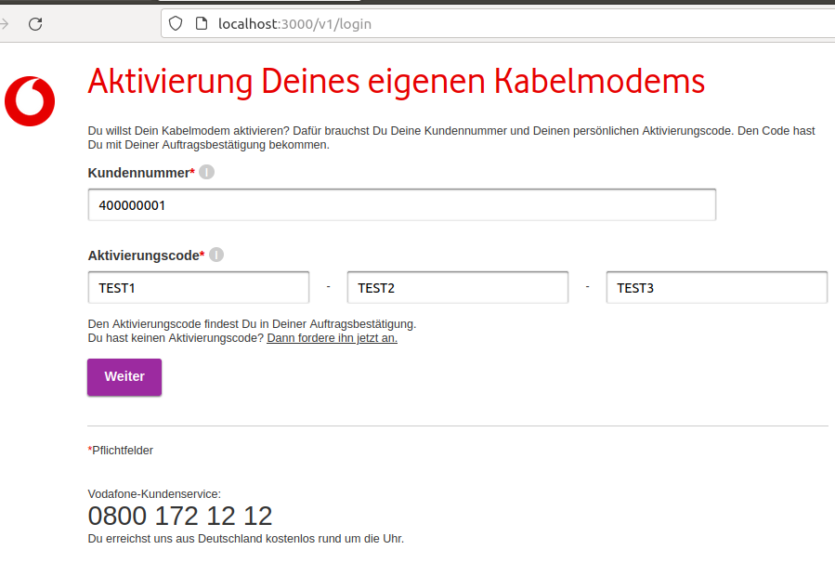

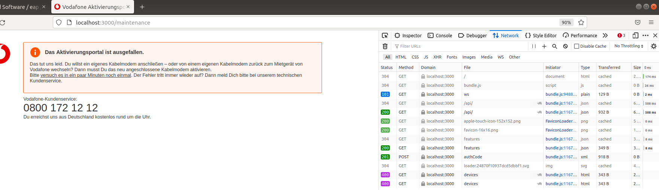

Case 12 : 500000000``` Return 500 on login request

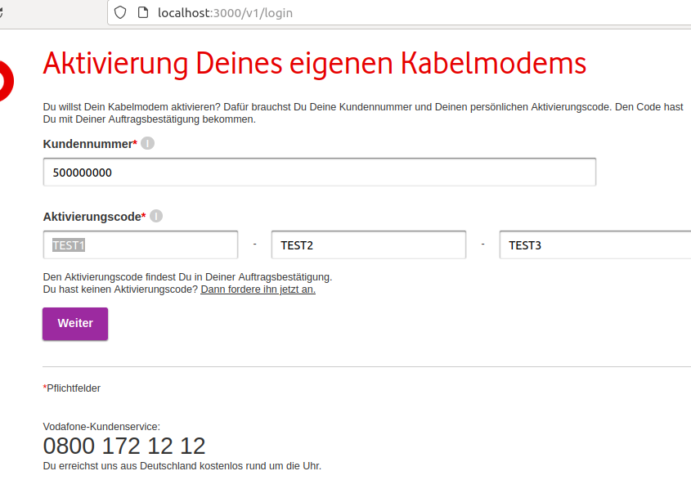

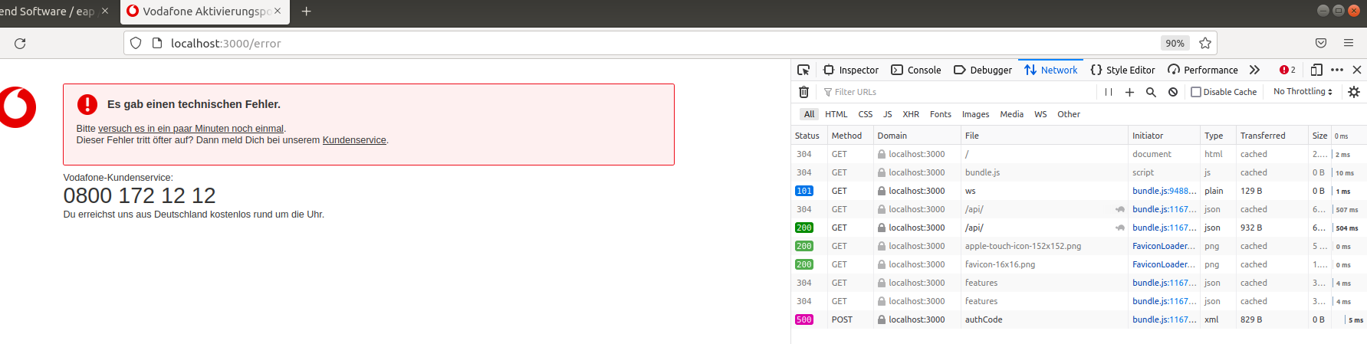

Case 13: 500000001``` Return 500 on GET /devices request

